c# program that receive alarms from tradingview
I need a c# program that receive alarms from tradingview.
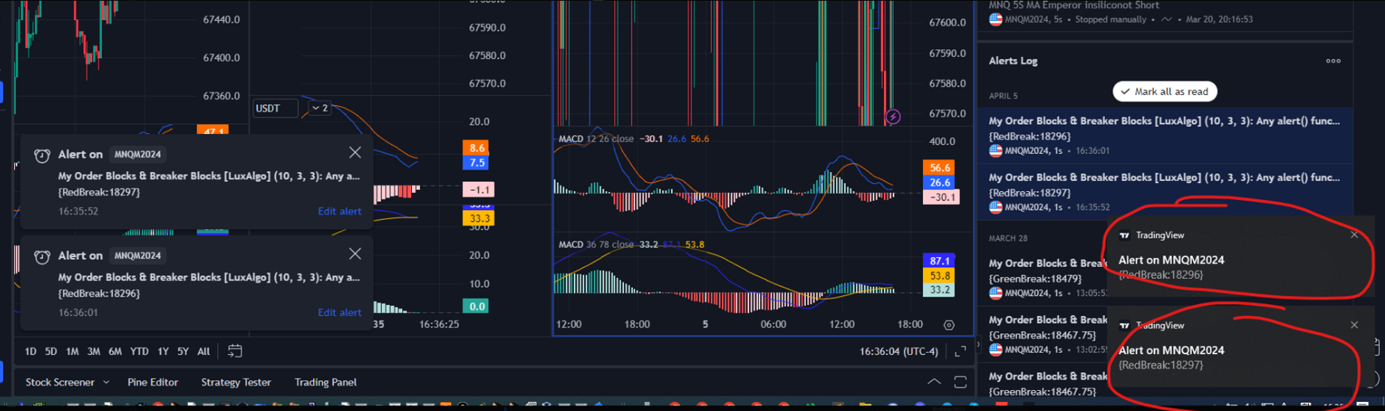
- the program receives the alarms and save in alarm.txt and clear the alarms.
- and you should clear these alarms.
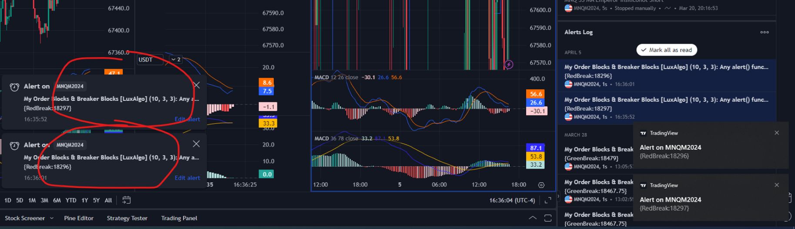
continue repeating 2 stage.

Time: 1 day
Budget: $100 (paypal, payoneer, trc20)
Before payment, you should send me the exe.
After I check the exe, I’ll pay
After payment, you send me the source code.

